Information on C5’s

Submitted by leaftye (Albuquerque, NM) on CorvetteForum.com

This thread is an evolution of a couple old threads and topics that come up over and over and over again. I’ve compiled most everything I know into this one thread. I’m always expanding and correcting this information; if anything is incorrect or missing, please post and point them out or PM me. I know I’m extremely fallible, yet humble, so feel free to shred this post to shreds, but do it constructively. As many of you have surely noticed, I’ve posted up lots of garbage in the past, but I’ve learned and will continue to learn. Because of the constant updates, posts down the road may get confusing, but just remember the information at the top is my latest and greatest. Enjoy!
Common Problems
Leaking Battery
Many C5's came with AC Delco Freedom batteries that had a tendency to have its case crack open near the battery posts. The leaking battery acid would drip down the side of the battery, down the funnel-like battery support, straight down onto the PCM and the wiring loom. It can also get onto the air conditioning lines. I believe they are the vacuum lines that control the movement of the interior vents. Sometimes car crippling damage would occur, sometimes not. At worst it would mean replacing the battery, the PCM, the wiring harness, grinding the rust off the frame to repaint it, changing the air conditioning lines and possibly swapping out another computer as well. This mostly happened on early C5’s because later C5’s used a gel-type battery that cannot leak, but I believe the problem resurfaced on 2003 or 2004 models again.
Check this out on any car you look at. Use an 8 mm monkey wrench, preferably a ratcheting closed-end version, to remove the battery cables. You also will need to remove a holding block on the front side of the battery. You will need a long extension to reach it. The battery basically lifts right out. Also remove the black plastic battery tray. Look beneath the tray for rust or white powder. Signs of both are evidence of battery acid damage. It would probably be best to move to the next Corvette unless you don't mind possibly tackling this repair in the future. It's possible that the car will throw codes for no apparent reason.
No matter what Corvette you buy, just make sure you replace the battery with a gel-type battery, like the Optima Redtop, sold at COSTCO for $100.
Grounding Problems aka CRAZY electrical gremlins!
Bill Curlee has a great thread on the problems that corroded ground connections can create, and how to clean out the grounds. The most problematic ground connections are behind the headlights on both sides. Check out Bill’s thread for detailed info: http://forums.corvetteforum.com/showthread.php?t=896875
From the above thread:
Many of you have asked me for help on solving electrical problems and I thought this would be VERY interesting!
My 1998 coupe would get the infamous "REDUCED ENGINE POWER", "TRACTION CONTROL FAILURE" and a host of random failure codes. After many, many hours of troubleshooting, replacing the BCM and TAC module, I solved most of the driveability issues. Still getting the random failure codes, I thought that I may be having ground issues. Back in June, I cleaned ALL of the chassis grounds and the car virtually stopped throwing the "RANDOM" failure codes. Just moving the wires in the chassis ground connector was enough to change the indications and make the issues stop happening.
I had a chance to speak with some GM C5 Trouble Desk Engineers when I went to Bowling Green, KY in April and they pointed out that MANY of the C5 electrical issues can be directly linked to chassis ground problems. The engineer even went as far as to recommending that I chop off the factory under hood chassis ground connectors and combine all of the wires into a single ground lug. Not wanting to just LOP off the factory connector, I took a chance and disassembled one of the ground plug connectors and to my surprise it was indeed full of corroded connections.
I strongly recommend that any C5 owner that has had or who are having electrical issues, examine and clean the chassis ground connectors. This may save you from needlessly replacing expensive electronics modules. Each connector can be disassembled and cleaned in about 20 minutes.
Just cleaning the ground connection between the chassis and the plug is only a band-aid solution. Now that I look back, when I cleaned my chassis grounds and solved my issues, I believe that when the connector is being removed to clean the connection between chassis and the connector, just the wires being moved inside the plug is what changed the indications and made everything work better. Disassembly of the chassis ground plug and cleaning the contacts inside the connector is the correct method of solving the issue!
I took some pictures of the under hood chassis ground connector and the corrosion that was in it. I cleaned the two connections on the frame rails and the left one was significantly corroded! Taking it apart and cleaning it is a very straight-forward procedure and I believe that if you follow this recommendation, you will be on the way to solving the many of the electrical issues.
Here are some detailed pictures of the ground connector and the corrosion that was found inside it!
Picture of the under hood Chassis Ground connector:
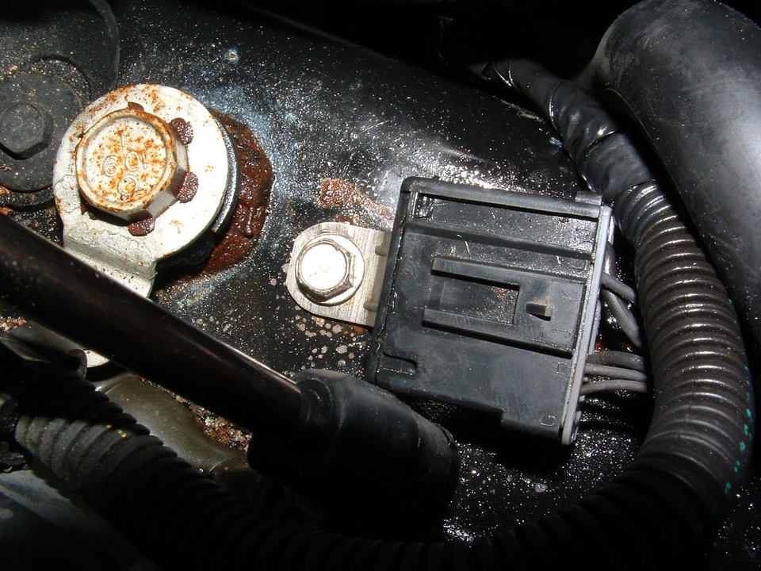
Corrosion inside connector! (You ain’t seen nothing yet!)
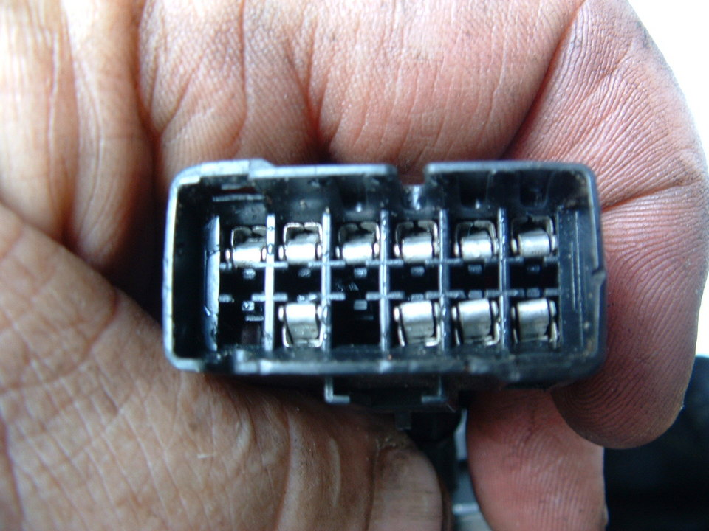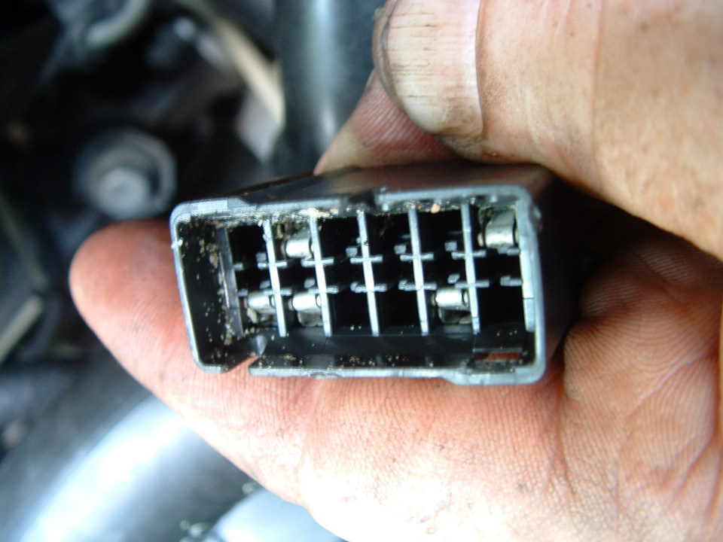
Next three photos are of the corrosion found on the connector terminals!
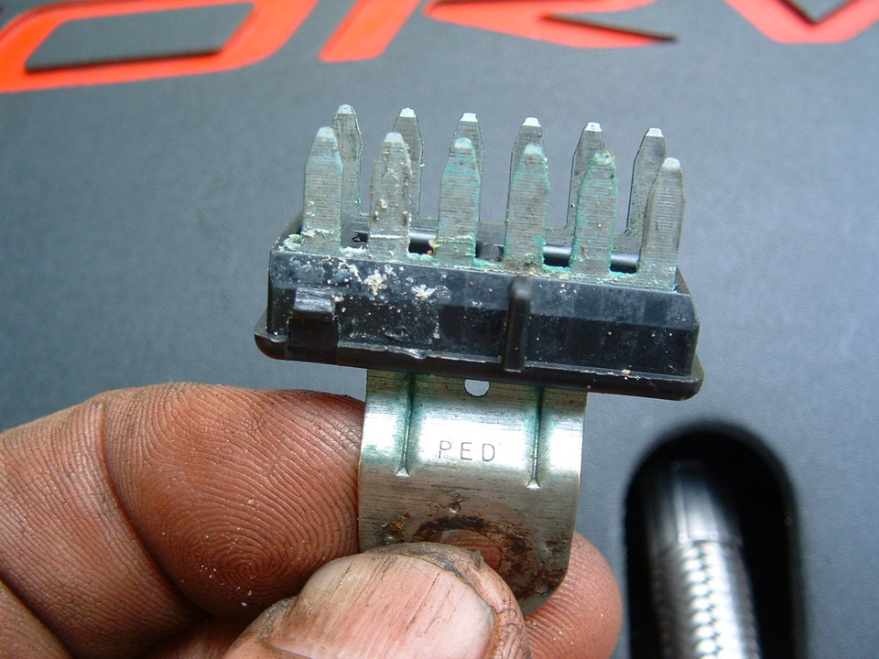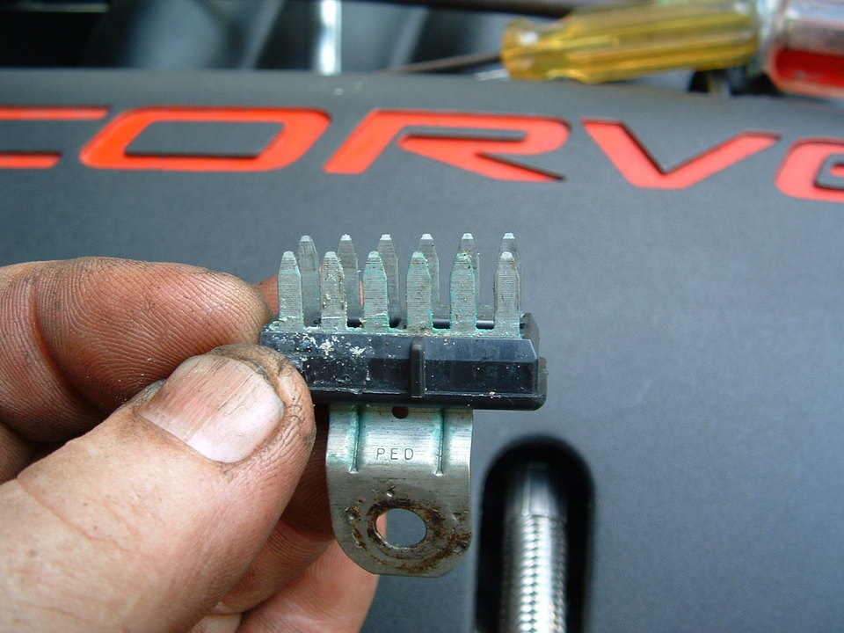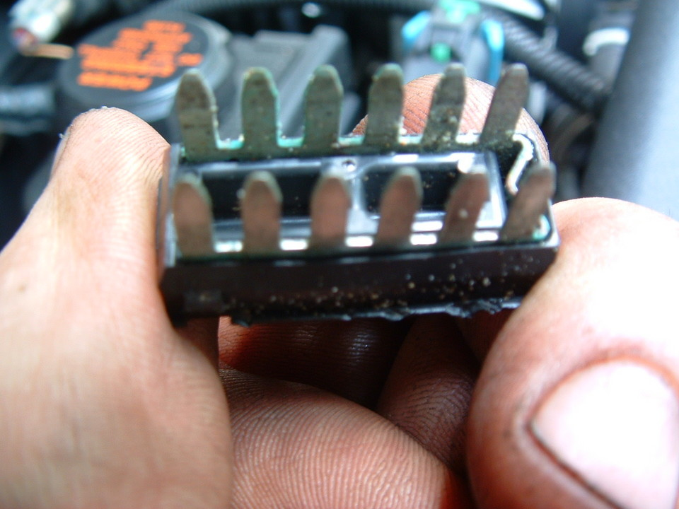
A small wire brush and contact cleaner works wonders!!
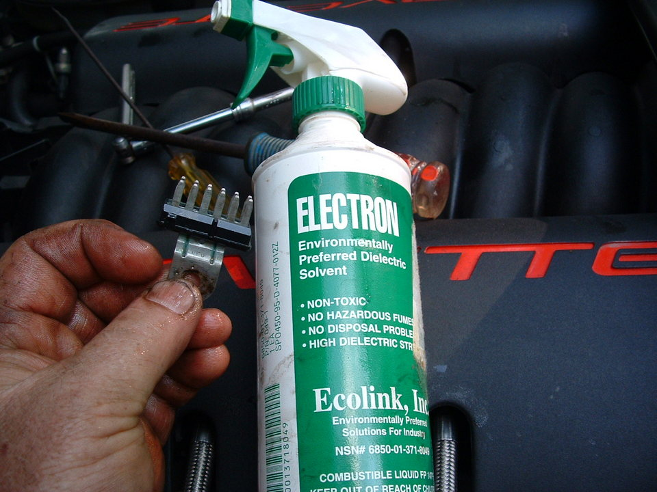
Self tapping ground screw and star washer. This is what you will need if the ground stud breaks off during removal!
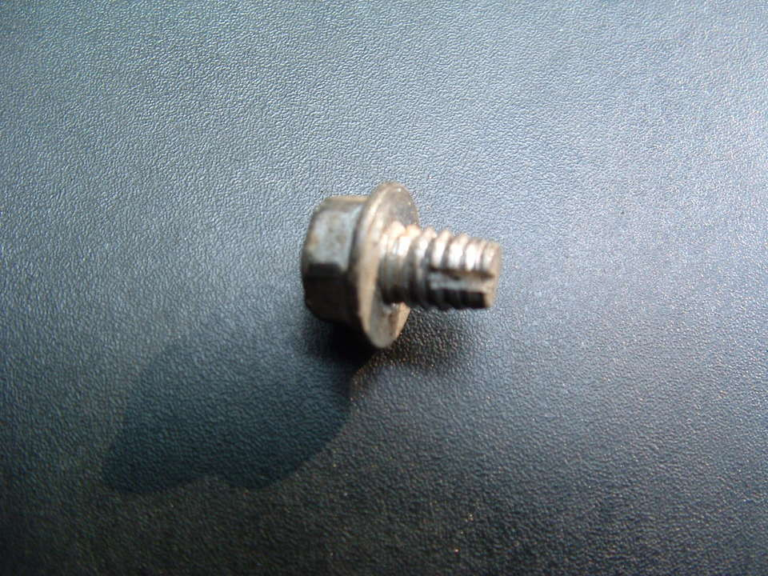
Seats
Corvette seats are delicate.
Sliding hard across the bolster can break it, causing it to flap side-to-side.
The leather is cheap, and there's little protection for it. It will wear out and form cracks, which is normal - for cheap leather.
The wire springs in the seat bottom, and the bars in the bolsters can also wear through the foam and leather, but that can be fixed by placing a layer of burlap between the springs and the foam.
Check the black plastic surround on the bottom of the seat to make sure it fits snugly against the leather, and isn't cracked. Older style plastic surrounds had a tendency to separate from the seat, but could be pushed back in. The newer style plastic surrounds can be used as a direct replacement, but one of the plastic studs may need to be ground off, or a hole will need to get punched into the leather.
The seats tend to rock back and forth by about a 1/4" during acceleration and braking. It can be fixed, but GM will not fix it. Some lucky owners can get the dealer to replace the frame under warranty. The seat backs swinging forward under braking is normal, and not considered a problem.
Here are a couple fixes:
Corvettemechanic.com --- must be a member
Rocking Seat Fix
Seat choice
Get the sport seats. The sport seats have a hole under the headrest. Some people put racing harness belts thru those loops. The seat frames and foam in both seats are interchangeable. Harness belt holes can be installed using Ford harness cutouts. Ask the dealership for them, they should know what it is without a part number. The foam in a standard seat will need to be cut, and sewing will have to be done, but it’s an easy job.
Headlight bezel plugs
These are 1-1/2" plugs that are located on the headlight bezels that would fall off on the older Corvettes. The new style plugs, have a twist-lock to prevent them from falling out.
Roof noises
If you buy a coupe with a removable roof, you can expect wind noise and some creaking. The wind noise will never totally go away, but if there's creaking, you can eliminate that by thinly applying dielectric silicone grease to the weather-stripping. It also prevents cracking, so do this to all weather-stripping, on any car.
Drive train rattling
The valve train makes a significant amount of noise at idle. It may sound like a sewing machine. Converting the valve rockers to true shaft-mounted roller rockers may help eliminate the valve train noise. Installing a big cam will make the noise louder.
During cold weather the rubber hood stops can also rub and rattle against the hood. Adjust and lubricate the rubber stops.
On manual transmission cars (M6 or M12), the transmission sounds like it is rattling when leaving the line. It is normal. It is the clutch throw-out bearing rattling around. Sometimes you'll hear a horrible rattle if you shut off the engine. If you press the clutch pedal in while shutting off the car, you won't hear it.
Shaky breaking
The front brake rotors warp easily under heavy braking…or at least that’s what uneducated drivers think. I tend to believe StopTech: http://www.stoptech.com/whitepapers...rotors_myth.htm
I verified this by lightly grinding my rotors with steel wool. Garnet paper is recommended, but I haven’t tried it.
If you insist the problem is warping, don’t turn the rotors since thinner rotors warp more easily. Resurfacing the rotors is only a temporary fix, one that is less effective each time your resurface the rotors due to the reduced thermal capacity of the rotors. Rotors are available for $25 at Napa and RockAuto.
Scraped front ends and rocker panels
Checking for scrapes is an easy way to tell if the car was treated well. It's almost impossible not to scrape the front end, but there are two metal crash bar loops that should prevent the bumper from scraping. The bumper itself should not have scrape marks on it. Check the underside of the tip of the bumper, and the bottom corners of the bumper. If the crash bar gets scraped enough, eventually it will wear down to the point where it needs to get replaced. It costs about $220 for the crash bar, nut-serts, bolts and insulators, and can be replaced in a couple of hours, just be sure to hook the hoses and electric connector back to the A.I.R. pump.
The rocker panels tend to get scraped on lifts and big speed bumps.
A & A Corvettes invented two products to prevent damage from both kinds of scraping. They have wheels that attach to the crash bar, allowing the car to roll on driveways instead of wearing down the crash bar. It will still scrape the spoiler, but the spoiler is a cheap wear item that takes only 2 minutes to replace without a lift or jack. They also make two aluminum strips that attached the frame next to the rocker panels, and they take the scrapes themselves instead of the rockers panels. Neither of the devices are visible unless looking under the car, and they are discreet enough to possibly be missed anyway. If you see these devices installed, you can be pretty sure the owner took good care of the car. Without this extra protection, you can expect to replace the crash bar and repair the rockers several times over the life of the car.
Hood seal weather-strip
The sides and back of the hood compartment have weather-strip installed from the factory. The front is left open. Many owners install weather-strip along this front edge. You may not even notice it since it looks identical to rest of the weather-stripping. This extra weather-strip helps keep the engine compartment clean and may also help the air intake system work better. This is another sign that the owner took good care of the car. The engine compartment stays pretty clean, but this is the "extra step".
Air Conditioning System
There are two kinds of climate controls. One is manual with knobs and the other is a dual-zone electronic system. The dual-zone system did cost more, but is not as reliable as the manual system. A leaking battery can affect both systems. A strong system is when the vents cannot be switched.
Over time, and especially in humid climates, the system can cause condensation to leak onto the passenger side carpet. There are three udders under the driver’s side cowl. There are slits on the bottom, much like real udders. Vigorously squeeze and massage the udders until the debris has fallen out. Stop laughing!
Squeaky steering wheel
When you turn the steering wheel, you may hear a squeak. It's just the plastic surfaces rubbing against each other. A shot of lubricant fixes this.
Squeaky/chirping/grinding wheel bearings
Drive slowly, better yet, coast along at low speeds with the windows open in a quiet location. Listen for a squeak from the wheels. Try turning in different directions. If you hear the rear wheels squeaking, you may have a worn wheel bearing. A replacement bearing costs $600 list, but you can usually find it for $400-450. I've heard that AutoZone has a better replacement for $126 by a company named Timken. The part is easy to replace if you can separate the ball joints. I had to buy a special Kent-Moore tool to do mine. This problem may persist safely for a few months, but eventually will become annoying. It seems to be a common problem, and more so for the rear wheel bearing. I've never heard of it happening twice to the same car, so if you fix it once, you're probably good for life. Several racers replace their wheel bearing every year.
A broken emergency drum clip may cause a false diagnosis. Be careful when removing and replacing the rear rotors.
Oil woes
Many late 2000 thru 2001 Corvettes burn a lot of oil when the engine is kept constantly over 4,000 rpm's. This is caused by ring flutter, which allows extra oil to seep past the oil control rings, but doesn't seem to cause any extra wear to the engine. Chevrolet has rebuilt and replaced engines for owners that complained about excessive oil consumption. Their policy is that while the engine isn't normally operated like that outside of racing, it is the owner's prerogative to drive around in second gear all the time if they want to. It is covered under the warranty.
The PCV system also has a tendency to suck oil back into the intake at high rpm's. It doesn't seem to cause any problems, other than a slight mess inside the intake manifold. The newer style PCV system can be installed, but this requires removing all the components in the top of the engine valley. Usually only racer's bother with the hassle. Several generations of PCV systems have had the problem, and at this time, December 2004, the PCV system still sucks oil into the intake.
The oil-sucking problem will cause carbon buildup in the cylinders. The dealership sells GM Top End Cleaner, and NAPA sells SeaFoam. The Top End Cleaner is not available in some smog states like California. Run a tube from the bottle into the hole for the PCV system behind the throttle body on the passenger side. Start the car, then start slowly sucking the solution into the engine. Don’t go too fast or the engine could lockup. As soon as the solution is gone, stop the motor for >4 hours, but preferably 12 hours. Be aware that when the engine is restarted, there will be a LOT of smoke!
The oil-sucking can be prevented by installing a catch can. AMW and Greddy make catch cans, but a homebuilt catch can may be built using a Campbell-Hausfield air tool oil separator from most tool stores, including AutoZone. The AMW and Greddy cans are ~$100, but look great. The CH can is $15-25 for all the parts, and you can see how much oil is in it.
Overheating and burning smells
Even though the engine can heat up to 220, even 240 degrees Fahrenheit, this is normal. The radiator will keep the engine cool enough unless the radiator is blocked. Reprogramming the PCM can allow the fans to turn on earlier. If the fans also cool an aftermarket oil cooler, make sure the oil occasionally gets to 220 degrees to allow condensation and fuel to evaporate away. Fan settings and oil thermostats are two different ways to do this.
It's not uncommon for plastic bags to get sucked up under the front bumper, and cover the radiator, thus causing the car to truly overheat. If this happens, take a quick peek under the bumper, and remove anything under there. Sometimes bags get stuck to the exhaust pipes too, causing quite a stench as they burn away.
Locked steering column
All C5’s, particularly manual transmission C5’s, and early C6 steering columns have a tendency to lock and stay locked. Usually it can be unlocked once, but just once. Some owners claim that vigorously shaking the steering wheel can unlock the steering wheel. Dealers are able to disable the locking mechanism with a modified locking plate. Currently this is the only real method to disable the locking mechanism. Basically the wheel will still try to lock, but there will be nothing for it to lock to. It’s like a door dead bolt with a slot cut into the door jamb. There is a $100 kit that disables the steering column lock, and can be installed easily, but enough car vibrations can cause the lock to fall into the locking plate, even while driving!
GM has a part (#88952428 or 88952428) that has a harness wiring jumper and different lock plate. Not sure what the difference in the kits are.
Faulty gas gauge
If you have bad gas, the fuel sender can be affected by the high sulfur content in the fuel, and cause the gauge to read empty. They car will still operate normally, and the gas gauge will work again if you use better gas, and will usually start again when you restart the car. It's just better to use good gas. Some people have had luck with running fuel filter cleaners thru the gas tank. New fuel senders do not seem to fix this problem. A product called Techron works well for cleaning sulfur deposits off the sending units.
Extremely high oil pressure reading
The oil pressure sensor can fail, but it is still okay to drive. Turn the car off, but with the key in the “on” position and check the oil pressure gauge. It should read “0”. If the oil pressure sensor is bad, it will show a positive reading. The oil pressure sender is located behind the intake manifold, and will require moving the intake manifold. The sender costs about $40 and is part # 12573107 or 12562230.
How-to
Noisy fuel pump
There are two fuel tanks, and two fuel pumps. One fuel pump continually pumps gas from the passenger side tank into the driver side tank, and is quiet. The main fuel pump is directly behind the driver’s seat, and can be annoyingly loud, especially on early C5’s. It's normal, and not a sign of a failing fuel pump. Chevrolet does have a bulletin out instructing how to better insulate against the sound of the fuel pump. This is merely an annoyance. A newer, quieter pump can also be installed.
Suspension squeaking
In cold weather you may hear the suspension creak when you go over speed bumps. To fix this, clean (optional) and lubricate the sway bar bushings. The adjustable metal sway bar end links on Hotchkis and T1 bars can also create loud clicking sounds. Most adjustable end links are quiet initially, but wear out and get noisy over time. Greasing and protecting the end links from dirt may prevent wear.
Tough shifting
The shifter in manually shifted Corvettes takes a strong arm to get it into gear. You really have to make sure that the shifter is fully in 1st and Reverse, or it will pop out of gear when you let the clutch out. This is not the fault of the car, but rather the fault of the driver.
Replacing the transmission fluid often helps shifting. Early transmissions have paper parts that require stock organic fluid because synthetic will destroy the paper and the transmission. Later transmissions, and all rebuilt transmissions, have carbon fiber parts that allow the use of synthetic fluids.
If it is especially tough to shift into 2nd or 4th gear, it's possible that the synchro's are worn out or the forks are bent. Do NOT force it into gear. Abuse creates and aggravates this problem. You can still drive, even quite well, without synchro's....or a clutch for that matter if you know how to rev match.
Some aftermarket shifters make it easier to make sure you're fully in gear, and prevent gear grinding, but they also vibrate, and require more effort to shift. The stock shifter has a tuned weight damper that changes the vibrations to a non-audible frequency. The shaking doesn’t annoy some people, and there are some fixes.
Inside tire spinning
If you make a tight turn, and the inner rear tire spins, the differential may need more friction modifier. This isn't really bad, just that the last mechanic didn't bother to "tune" the differential properly. Aftermarket gear fluid from Royal Purple, Amsoil and Redline do not require additional friction modifier.
Interior rattles
The visors may rattle when they are put up, but if you flip them down, the rattle goes away. Squeezing the mirror lid down seems to take care of it. Try gluing a piece of felt or velcro between the mirror and lid to see if that fixes it. Caravaggio also makes replacement leather visors, but they go for $400.
The stereo is Bose, and to go along with the historically crappy build quality of Bose products, Bose has graced the Corvette with Bose emblems on the door speaker covers that rattle when you play music with bass. A Bose system doesn't exist that puts out good bass, but the system still manages to rattle the emblems when playing Country, Hip Hop, or Techno at moderate volumes. Check this problem by having a passenger and yourself put a finger on the emblems with music playing. Glue the emblems down to fix it.
If the roof isn't tightened down enough, it will rattle. There are some adjustment screws in the roof to make this adjustment.
Belt Chirping
During cold weather, the belt can chirp. Goodyear Gatorback belts from AutoZone don’t chirp.
Sticky Hatch
During cold weather, the hatch may pop up slowly, or not at all. Spray the latches with silicone grease until they come up properly. If the struts do not hold up the hatch, try lubing the strut bars.
Leaky butt
The differential can leak from the side covers. The problem has to do with the design. The lip on the casing is not wide enough to create a proper seal with the cover. Resealing the covers can be successful, but many dealers do not use the correct sealant.
Active Handling Control
This allows you to keep some control of the car even when you do really stupid stunts. It doesn't bend the laws of physics, but will keep the car pointed where you are steering. You may still slide off the road, but at least the car will be pointed in the direction you were steering! One of the sensors is located around the passenger seat, and needs to be considered when installing a racing bucket. If you move that sensor, active handling will not know how to balance the car, and can be very dangerous. Active handling came out mid-19998 model year.
Jacking
The C5 was the first car to use hydroformed frame rails. Hydroformed rails are quickly becoming a common platform for new cars, but not many shops are prepared to lift these vehicles. The C5 requires an adapter for regular jacks and lifts to fit the jacking points. Make your own adapters with a hockey puck (or two) with a 1 1/2" eye bolt screwed thru the center. Stick the eye bolt thru the slit in the jacking point, turn 90 degrees, place jack under adapter and jack away....if you can get the jack under the car. You may have to use ramps. The C5 is so low that most people make their own wooden ramps....Rhino Ramps are too steep.
Key Fobs
There are basically two different kinds of key fobs and they are not compatible with each other.
1997-2000, but 2000 does not have the Passive Lock feature
2001-2004
These problems, and many others, are addressed at the www.corvetteactioncenter.com in the Tech Center -> Knowledge Base.
While these problems do sound numerous and severe, just remember that JD Power considers this a very reliable car. If you buy a Corvette, consider yourself fortunate that there are many resources available to help you locate and correct problems.
Secrets of the C5
Copied from www.corvettemechanic.com
The little yellow “helper light” on the bottom of the rear-view mirror that illuminates the shifter area.
Quote:
That you can put your key in the driver’s door and turn it twice towards the front to unlock the passenger door and a third time to pop the trunk.
That you can pop the trunk and also pop the gas cap cover by pulling on metal lines hidden in the back.
The little slotted cover on the dash behind the steering wheel is where the inside air temperature sensor is located.
All of the option codes are in the glove box.
Tire inflation recommended pressures are on the driver’s door.
The thing that looks like a little LED near the DIC buttons is a light sensor.
The thing that looks like a little LED near the defroster vent is a UV sensor for determining A/C usage to compensate for the heating effect of the sun.
The build sheet is in the front re-bar.
If you leave your turn signal on, in about 1 minute it will start to ding (loud enough to hear over the stereo) to let you know you have old timers disease.
You can reset the oil life by pumping the gas pedal three times (but not with the engine running).
Hold down the reset button while on one of the trip odometers and it changes that reading to the miles you’ve traveled since last starting the engine.
Hold down the Active Handling button for 5 seconds to engage “Competitive Driving” on cars equipped with active handling (2000 and previous years must be stopped.)
If you pull the seatbelts all the way out while you’re buckled in, they ratchet back in to hold you tighter into the seat. (then move the seat forward to make it extra snug).
Simply remove fuse #2 under the hood and your DRLs will be out permanently. Only thing affected is that when you unlock at night using the key fob your front turn signal lights and back up lights will not flash. Your front turn signals will operate normally, however.
The side-view mirrors can twist both forward and backward, decreasing the chance of damage if struck.
There is a release opening with a flap to let air out of the car when the hatch is closed. It is located just above the driver side rear compartment behind the carpet and on the side of the car. Not that it really works well.
Also you can ground your amp to a screw/bolt that holds the rear middle compartment to the frame.
If you have a 6-speed car you can pop the trunk when the car is running by lifting the e-brake.
There is a spot on the driver side just out of the middle compartment under the carpet for the lug nut key. You should have a compartment on the drivers & passenger’s side (in the trunk) and a center compartment. On the left (drivers) side of the center compartment, on the left side where the center cover fits, there is an ‘indent’ that holds the wheel lock key.
If you turn on the headlights, then go to parking light position, the lamps remain up but the headlights are not left on.
If you have the passive entry feature: If you lock the keys in the car, wait a few minutes and then shake the car. That will unlock the car.
HUD has a shift light for the manuals.
You can easily shift the M6 trans up or down without the clutch if you match revs. (Not great for longevity, however.)
You can eject the CD from the in-dash player without turning on any power. Don’t even need key in the ignition.
The cruise will disengage if you purposely make sharp side to side turns while cruising at say 60-80 mph.
When the engine is shut off, you can get the odometer reading by turning on the parking lights.
You can program setting #3 (both memory buttons at once) in the seat memory to run the seat back and steering wheel forward for getting in/out of the car with the engine running.
If you hate DRLs, you can pull the e-brake ONE click and they go off.
Power
First you need to know how your car is doing. A trip to the dyno can give you quick answers.
Tuning software can diagnose and tune your car. LS1Tech and HPTuners are two popular tuning packages. At some point in the future, both packages will be able to do scanning with incorporated wideband sensor support. At this time, December 2004, only HPTuners can do both.
Popular upgrades:
Cold air intakes: Vararam, Halltech, Blackwing, zip-tie
Intake manifolds: LS6, LS2, LSX, Weiend, sheetmetal
Cat-back exhausts: B&B, Borla, Z06 Ti, Corsa
Long tube headers: LG, Kooks, TPIS, Stainless Works, Breathless, Jet-Hot, GHL
Superchargers: ATI (go to A&A), Vortech, Magnacharger
Turbochargers
Stroke & bore
Head & cam packages: TEA, AFR, TSP, Patriot, Cartek
Tires: Kumho Ecsta MX, Nitto Extreme RII
Quote:
The convertible and coupe (it's really a targa) come with run-flat tires, with 17" wheels in the front, and 18" in the rear, with tire pressure sensors. The Z06 comes with non run-flat tire, but has a tire repair kit. Switching from run-flat tires to regular tires typically allows the C5 to ride softer, accelerate faster, and corner harder, but if you use the tire repair kit (goo) on wheels with the unobtainium tire pressure sensors, you'll destroy the sensors. No C5 has a spare tire. The best way to improve the handling of any car is usually thru the tires.
Aerodynamics, gearing and top speed
The hardtops and Z06 have shorter rear windows, are less aerodynamic, noisier, and weigh less than the standard C5 couple like mine. Even though the Z06 has more horsepower than standard C5’s, they have a lower top speed than manual Z51 C5 coupes. This is due to both aerodynamics and gearing. All C5’s top out at redline in 5th gear, so a taller 5th gear, or much shorter 6th gear, or taller redline is required to go faster. All else being equal, a Z51 coupe will still go faster than a Z06. Above 190 mph, air builds up under the front of the car. This can be solved with a vented hood like the ACP C5-R or MCM hoods.
Weight reduction
You can achieve substantial weight reduction with the following modifications, while still having a car that's very comfortable to drive. Most of these modifications will directly increase (and decrease in a few cases) the safety of the car, while safety is indirectly improved due to the better handling and limits of a lighter car. Fighter pilots say "speed is life". Acceleration, deceleration, and lateral acceleration are all forms of acceleration, and lighter cars accelerate better in each of these ways because the tires have less mass to control....thus a lighter car is a safer car. Lighter cars have better moments of inertia which allows them to turn in more easily and roll less. Lighter cars are also easier on the tires and gas.
All the stage weight estimates are typically wild butt guesses, but it makes it easy to see what is possible. The weight listings in the separate weight posting is MUCH more reliable.
Stage I: Streetable weight reduction modifications
Non-popup headlights (~40 lbs)
Braking rotors with an aluminum hat, or titanium rotors (unproven on street cars) (~20-30 lbs)
Carbon fiber hood (~12 lbs)
Z06 (thinner) windshield and side windows (~4 lbs)
Non runflat tires (~20 lbs)
Slicks (~30 lbs)
Z06 wheels (~4 lbs est.)
Corsa titanium exhaust (~35 lbs)
Long tube headers (~20 lbs)
Halltech aluminum alternator & bracket (10 lbs)
Carbon fiber driveshaft (~2 lbs)
Newer torque tube
Less options [HUD, electronic A/C, Active Handling, seat/mirror/steering wheel memory, CD changer] (~50 lbs)
Less gasoline and wiper fluid (No wiper fluid=9lbs, 6 lbs for every gallon of gas in that 18 gallon tank....~81 lbs for autocrossing)
Remove cargo net
Remove targa top (~20 lbs)
Remove BCM’s
Remove C5 "appearance mods" - exhaust plates, doorsill covers, etc.
Remove fuel rail covers
Replace stock crank pulley with aluminum aftermarket pulley
Replace steel dampener with aluminum dampener
Replace stock targa top with lexan piece (coupes)
Replace water pump with electric water pump
Replace battery with smaller battery
Replace non-stressed fasteners with aluminum or titanium fasteners
Replace leaf springs with coil over shocks with titanium springs
Replace steel shifter with aluminum shifter and Delrin or titanium shift knob
Remove all loose change, CD's, golf clubs, misc. items, from center console, hatch area, and glove box
Empty your pockets of extra change, PDA's, cell phones, keys, lead plates, or whatever other junk you lug around
Go on a diet
Stage II: Hardcore semi-streetable weight reduction modifications
Aluminum flywheel (~10 lbs)
Lighter clutch like Exedy or Quartermaster (~10 lbs)
Racing buckets (40-50 lbs)
Remove tire repair kit (Z06)
Off-road x-pipe (10 lbs)
Remove floor mats
Remove fog lights
Replace stock hood, fenders, doors, roof, hatch and bumpers with aftermarket carbon fiber pieces
Stage III: Track only weight reduction modifications
Racing steering wheel & delete both airbags (~30 lbs, but get a 4-6 point harness)
Use unpadded aluminum or carbon fiber steering wheel
Run open headers
Remove column locking hardware
Remove interior – passenger seat, carpets, speaker panels, head liner, dash, center console, glove box, door panels, sun visors, rear view mirror, insulation, etc.
Remove A/C Compressor
Remove A/C controls and ducting
Remove AIR pump system
Remove factory radio, speakers, and/or CD changer, and unnecessary wiring
Remove HUD projector
Remove windshield wiper fluid reservoir and pump
Remove windshield wipers and motors
Remove stock cat back
Remove power steering pump
Remove front sway bar (drag only)
Remove ABS, TC, AH hardware and sensors (drag only)
Remove fender wells
Remove headlight assembly, turn signals, taillights and reflectors
Remove/shave side mirrors
Remove torque tunnel cover
Remove seat belts
Remove parking brake
Remove side windows and motors
Remove power locks and power windows
Remove side impact beams
Replace stock front and rear glass with polycarbonate “glass”
Rebuild motor with Al or Ti connecting rods, Ti valve spring retainers and pushrods
Port the heads
Remove all flashing from the engine, then polish
Replace valve covers with magnesium or carbon fiber parts
Strip entire car, acid wash chassis, put car back together.
Reducing unsprung weight—not all is streetable
Replace stock wheels with forged 1-piece wheels
Use 3-piece wheels by Jongbloed, Kodiak, CCW, BBS
Skinny front wheels (drag only)
Use Ti fasteners on 3-piece wheels (~1 lbs per wheel)
Use lighter non-runflat tires, or even Hoosier nylon corded slicks
Use lighter calipers
Replace stock rotors with 2-piece, unvented or titanium rotors
Replace wheels studs with titanium studs
Replace lug nuts with aluminum or titanium lug nuts
Remove tire pressure sensors
Use rubber valve stem without a cap
Balance the wheels without tires or balancing weights, then mount tires

C5 Suspension
Swaybars
18.5 lbs --- T1 front anti-swaybar w/OEM adjustable endlinks & bushings ---Source
8.5 oz --- T1 OEM adjustable endlink --- Source
3 oz --- T1 OEM (endlink) bolt, nut and spacers --- Source
5 oz --- T1 OEM rear bushings (2) --- Source
4.1 lbs --- Z51 rear anti-swaybar w/OEM bushings --- Source
3.6 lbs --- Z51 rear anti-swaybar --- Source
4.5 oz --- Z51 rear OEM bushings (2) --- Source
18.5 oz --- Z51 OEM endlinks (2) --- Source
9.5 oz --- QA-1 endlinks --- Source
6.5 oz --- Lowe's 1/2" hole, 1.5 mm (avg) thick, 2" diameter (8) --- Source
4 oz --- Lowe's 1/2" hole, 2.25 mm (avg) thick, 3.5 cm diameter (8) --- Source
Rotors
4.8 lbs --- ZMI titanium ---Source
14 lb --- rear left brake rotor from Napa, made in Canada, part# 86702 --- Source
14 lb, 4 oz --- rear right brake rotor from Napa, made in Canada, part# 86703 --- Source
18 lb, 14 oz --- front right brake rotor from Napa, made in USA, part# 86700 --- Source
18 lb, 10 oz --- front left brake rotor from Napa, made in Canada, part# 86701 --- Source
Calipers
5.8 lbs --- ZMI --- Source
1/2 oz --- single Speedbleeder --- Source
Pads
1 lb, 2 oz --- PFC Z-rated brake pads, single side, rear, without shim --- Source
1/2 oz --- PFC brake pad rear shim, single side --- Source
2 lb, 5 oz --- PFC Z-rated brake pads, single side, front, without shims --- Source
3 oz --- PFC brake pad front shims (2), single side --- Source
Wheels
19.2 lbs, front; 21.4 lbs, rear --- 97-99 OEM wagon --- Source
22 lbs, front; 29 lbs, rear --- 97-99 OEM wagon --- Source
17 lbs, front; 19.5 lbs rear --- 97-00 OEM magnesium --- Source
17.5 lbs, front; 19.5 lbs, rear --- 97-00 OEM magnesium --- Source
18.08 lbs, front; 20.06 rear --- 00 OEM standard, thin spoke, high polish --- Source
17 lbs, front; 20 lbs, rear --- 00 OEM standard, thin spoke, painted, no sensors or centercaps --- Source
16 lbs, front; 20 lbs, rear --- 01 OEM standard high polish --- Source
19.6 lbs, front; 21.4 lbs, rear --- 01 Z06 forged --- Source
19.2 lbs, front; 21 lbs, rear --- 02-04 Z06 cast/spun --- Source
24 lbs, 18x10.5 --- 00+ repro high polish --- Source
28 lbs, front; 32 lbs, rear --- Z06 chrome repro --- Source
23 lbs, front; 26 lbs, rear --- Z06 chrome repro --- Source
23.5 lbs, front; 24.5 lbs, rear --- Z06 Motorsports, polished --- Source
20 lbs, 17x8.5, 58mm offset, front; 23 lbs, 18x9.5, 65mm offset, rear --- PWO --- Source
22 lbs, 18x10.5, 58mm offset, front --- HRE 545 w/clear center --- Source
27 lbs, 18x12, 74mm offset, rear --- HRE 545 w/clear center --- Source
Lugnuts
1.5 oz --- OEM open lugnut --- Source
Tires
29.5 lbs, front; 32.5 lbs, rear --- Goodyear EMT, stock size --- Source
27 lbs, front; 33 lbs, rear --- Bridgestone S03's, stock size --- Source
26.4 lbs --- Goodyear GS-C 275/40R17 --- Source
12 lbs, 275/40x17; 15 lbs, 315/35x17; 16 lbs, 305/30x18 --- Hoosier A3S03 --- Source
28 lbs, 275/40x17=28lbs; 30.5 lbs, 315/35x17 --- Goodyear ZR "S" Rains --- Source
25 lbs, 275/40x17; 28 lbs, 315/35x17 (shaved to 6/32") --- Goodyear GS CS --- Source
23lbs, 265/40x17; 24.5 lbs, 275/40x18; 25.5 lbs, 295/35x18 --- Goodyear F1 GS CS --- Source
27 lbs, 265/40R18; 28 lbs, 315/40R18 --- Goodyear GS F1 SC --- Source
25 lbs, 255/40R17 --- Bridgestone Potenza S02 --- Source
27 lbs, 275/40R18 --- Bridgestone Potenza S02 --- Source
29 lbs, 285/30R18 --- Bridgestone Potenza S02 --- Source
30 lbs, 285/30R18 --- Bridgestone Potenza S02 --- Source
30 lbs, 295/30R18 --- Bridgestone Potenza S02 --- Source
29 lbs, 295/35R18 --- Bridgestone Potenza S02 --- Source
28 lbs, 245/45R17 --- Kumho Ecsta ASX --- Source
28 lbs, 245/45R17 --- Kumho Ecsta 711 --- Source
29 lbs, 245/45R17 --- Kumho Ecsta Supra --- Source
25 lbs, 245/45R17 --- Kumho Ecsta MX --- Source
32 lbs, 245/45R17 --- Kumho Ecsta MX --- Source
26 lbs, 245/45R17 --- Kumho Ecsta Victoracer V700 --- Source
30 lbs, 265/40R17 --- Kumho Ecsta Supra --- Source
32 lbs, 275/40R17 --- Kumho Ecsta ASX --- Source
20 lbs, 275/40R17 --- Kumho Ecsta MX --- Source
36 lbs, 275/40R17 --- Kumho Ecsta MX --- Source
25 lbs, 285/30R18 --- Kumho Ecsta V700 --- Source
TBD lbs, 295/35R18 --- Kumho Ecsta ASX --- Source
30 lbs, 295/35R18 --- Kumho Ecsta Supra --- Source
20 lbs, 275/35R18 --- Kumho Ecsta MX --- Source
31 lbs, 295/35R18 --- Kumho Ecsta MX --- Source
26 lbs, 305/30R18 --- Kumho Ecsta V700 --- Source
28 lbs, 315/35R18 --- Kumho Ecsta V710 --- Source
30 lbs, 335/30R18 --- Kumho Ecsta V700 --- Source
Wheel & Tire combined weight
45 lbs, front --- 97-00 OEM magnesium w/Nitto 275/40-17 (1/2 tread) --- Source
50 lbs, rear --- 97-00 OEM magnesium w/Yoko 295/35-18 AVS Sport non-runflats --- Source
47 lbs, front --- 97-00 OEM magnesium w/OEM 245/45-17 runflats --- Source
53 lbs, rear --- 97-00 OEM magnesium w/OEM 275/40-18 runflats --- Source
50 lbs, 17x8.5, 58mm offset, front --- PWO w/OEM 245/45-17 runflats (1/2 tread) --- Source
C6 Suspension
Z51 rotors
Estimates based on information above and http://forums.corvetteforum.com/showthread.php?t=880807
17 lb, 14 oz --- front rotor
24 lb, 16 oz --- rear rotor
Drivetrain
Clutch/Flywheel
23.3 lbs --- O.E. iron flywheel --- Source
44.8 lbs --- O.E. flywheel/clutch assembly --- Source
49 lbs --- Z06 clutch/flywheel assembly --- Source
42.8 lbs --- Z06 stock --- Source
36.7 lbs --- Exedy Single Disk --- Source
36.7 lbs --- Exedy Dual Disk --- Source
12.4 lbs --- Fidanza flywheel --- Source
33.9 lbs --- Fidanza flywheel & SPEC clutch assembly --- Source
14 lbs --- Quartermaster 5.5" 3-disc clutch/flywheel/hardware --- Source
115-129 lbs --- T56 transmission, TUET1806 --- Source
21 lbs --- DTE A4 Differential Strut Kit, Stage I --- Source
Motor and accessories
457.6 lbs, LS1 auto; 497.2 lbs, LS1/LS6 manual --- LS1/LS6 dressed --- Source
443 lbs --- LS2 dressed --- Source
~600 oz --- LS1/LS6 connecting rods --- Source
434 gm --- LS1/LS6 piston --- Source
76 gm, intake; 63 gm, exhaust --- '02 LS6 valves --- Source
99 gm, intake; 86 gm, exhaust --- LS1 valves --- Source
11.2 gm --- LS1/LS6 retainer --- Source
7.2 gm --- Comp Ti retainer --- Source
15 lbs --- A.I.R. system & plumbing --- Source
30 lbs --- AC/condenser/lines/oil holder/brackets/pulleys --- Source
10-3/4 oz --- airbridge --- Source
1 lb, 14 oz --- radiator top cover with screws (x4) --- Source
1 lb, 12 oz --- fuel rail covers --- Source
16 lbs --- P1SC head unit --- Source
14 lbs --- A&A single intercooler --- Source
Batteries
13 lbs --- Odyssey/Dynabatt/Hawker racing battery --- Source
13.5 lbs --- Genesis G16EP, LWH=7.15x3.01x6.65, CC=280 --- Source
15 lbs --- PC 680, LWH=7.27x3.12x6.67, CC=280 --- Source
23 lbs --- SVR SVR28-12, LWH=6.88x6.50x4.88 --- Source
23 lbs --- Genesis G26EP, LWH=6.57x6.92x4.96, CC=470 --- Source
26 lbs --- Odyssey PC 925, LWH=6.69x7.05x5.04, CC=470 --- Source
26 lbs --- SVR SVR33-12, LWH=7.75x5.00x7.25, CC=500 --- Source
26 lbs --- Optima Yellow Top 51, LWH=9.25x5.00x9.00, CC=500 --- Source
32.8 lbs --- AC Delco 75P-7YR, LWH=9.50x7.10x7.30, CC=550 --- Source
32.9 lbs --- Genesis G42EP, LWH=7.78x6.53x6.72, CC=630 --- Source
35.4 lbs --- Odyssey PC 1200, LWH=7.87x6.66x7.55, CC=630 --- Source
33.1 lbs --- Optima Red Top 75/35, LWH=9.31x6.81x7.63, CC=650 --- Source
37.7 lbs --- AC Delco 34P-7YR, LWH=10.3x6.80x7.80, CC=650 --- Source
36 lbs --- Exide Select Orbital 75, LWH=9.00x7.00x7.44, CC=690 --- Source
38.8 lbs --- Optima Red Top 34/78, LWH=10.0x6.88x7.81, CC=750 --- Source
38 lbs --- Exide Select Orbital 78, LWH=10.1x7.00x8.1, CC=770 --- Source
45.6 lbs --- AC Delco 65P-7YR, LWH=11.9x7.50x7.60, CC=800 --- Source
57 lbs --- SVR SVR80-12, LWH=10.6x6.50x6.25, CC=800 --- Source
58.7 lbs --- Odyssey PC 1700, LWH=13.02x6.62x7.68, CC=930 --- Source
Exhaust
Headers with H-pipe unless noted otherwise
68 lbs --- 97 stock double wall manifolds & h-pipe --- Source
72.5 lbs --- 02 cast iron manifolds with pup cats & h-pipe --- Source
46 lbs --- GHL 1-3/4" headers w/3" collectors & 3" Random Tech cats and x-pipe --- Source
52 or 61 lbs --- FLP LT's w/cats --- Source
49 lbs --- Kooks LT's w/high-flow cats --- Source
48.5 lbs --- LGM Pro LT's w/high-flow cats --- Source
45.4 lbs --- QTP LT's w/high-flow cats --- Source
50 lbs --- Stainless Works w/cats --- Source
63 lbs --- SuperMAXX LT's w/high-flow cats --- Source
Cat-back Exhaust
14 lbs per side --- Z06 Ti --- Source
13.5 lbs per side --- Z06 Ti --- Source
15-16 lbs per side --- Z06 Ti --- Source
17 lbs per side --- Z06 Ti --- Source
22 lbs per side --- OEM steel --- Source
24 lbs per side --- OEM steel --- Source
19 lbs --- B&B PRT's --- Source
19 lbs --- Borla Stingers (2-tip) --- Source
22 lbs --- Borla Stingers (4-tip) --- Source
Universal Components
12.0 lbs --- Random Tech X-pipe --- Source
5.8 lbs --- Random Tech left cat --- Source
5.7 lbs --- Random Tech right cat --- Source
2.5 lbs --- Dynatech clamps (4) --- Source
Body
9.0 lbs --- Window glass (left) --- Source
9.0 lbs --- Window glass (right) --- Source
3.0 lbs --- Exterior rear view mirror (left) --- Source
3.0 lbs --- Exterior rear view mirror (right) --- Source
6.2 lbs --- Stock tunnel plate --- Source
15.4 lbs --- Elite Engineering 304 SS, 0.134" tunnel plate, uncoated --- Source
9.4 lbs --- Elite Engineering aluminum 1/4" tunnel plate, uncoated --- Source
9.6 lbs --- Elite Engineering aluminum 1/4" tunnel plate, coated --- Source
14.6 lbs --- Elite Engineering aluminum 3/8" tunnel plate, coated --- Source
9.2 lbs --- LAPD 1/4" 6061-T6 aluminum Tunnel Heat/Insulator/Chassis Re-Enforcement Plate, coated --- Source, Source
12.2 lbs --- LAPD 3.8" 6061-T6 aluminum Tunnel Heat/Insulator/Chassis Re-Enforcement Plate, coated --- Source, Source
12.7 lbs --- VNM 304 SS BackBone, coated --- Source, Source
1/2 oz --- part# 11515757, crashbar bolt --- Source
1/4 oz --- part# 10281493, crashbar nutsert (big) --- Source
1/2 oz --- part# 10281487, crashbar nutsert (small) (x4) --- Source
1/2 oz --- part# 10#11515638, radiator/bumper nut-speci (x4) --- Source
1/2 oz --- part# 11513568, radiator/bumper screws (x3) --- Source
1 lb, 14 oz --- US headlight with bulbs --- Source
1 oz --- front spring to subframe bolt --- Source
502 lbs --- C5 frame --- Source
14 lbs --- Motor City 100% carbon fiber hood --- Source
24 lbs --- Motor City 50% carbon fiber, 50% fiberglass hood --- Source
Interior
3.5 lbs --- Driver side air bag --- Source
8.5 lbs --- Passenger air bag --- Source
3.5 lbs --- Driver side seatbelt --- Source
4 lbs --- Interior fan motor --- Source
8 lbs --- Front speakers --- Source
18.0 lbs --- HVAC (base under dash unit --- Source
4.0 lbs --- Blower motor (Heat/AC) --- Source
2.0 lbs --- HVAC plastic ducts --- Source
4.0 lbs --- Airbag/glove box aluminum support --- Source
2.0 lbs --- Aluminum center console support --- Source
1.0 lbs --- A/C control head --- Source
2.0 lbs --- Dash vent duct --- Source
1.0 lbs --- Knee bolster support (white foam) --- Source
1.0 lbs --- Bose radio amplifier box --- Source
3.0 lbs --- Radio, AM/FM/CD --- Source
7.0 lbs --- Door module, harness, regulator (left) --- Source
7.0 lbs --- Door module, harness, regulator (right) --- Source
3.0 lbs --- Glove box assembly --- Source
3.0 lbs --- Door speaker (left) --- Source
3.0 lbs --- Door speaker (right) --- Source
3 lb, 8 oz --- driver side seat belt and fasteners --- Source
11 oz --- CD changer pack, no CDs --- Source
6-1/2 oz --- 12 CDs --- Source
2 lb, 2 oz --- trunk side storage covers, both --- Source
1 lb, 10 oz --- passenger floormat --- Source
Seats
Sparco --- Source
I'm using the Sparco Evo 2 as the largest possible seat that can fit, so all the seats below should fit. 20.91"/531mm base, 23.66"/601mm shoulder
18.00 lbs --- Sprint (steel tube)
15.00 lbs --- Ultra (fiberglass)
16.50 lbs --- Off Road (fiberglass)
18.50 lbs --- All Road (fiberglass)
21.50 lbs --- Pro 2000 (fiberglass)
13.00 lbs --- Pro 2000 (carbon fiber)
18.50 lbs --- Evo (fiberglass)
12.50 lbs --- Evo (carbon fiber)
20.00 lbs --- Evo 2 (fiberglass)
17.50 lbs --- Pro WRC (fiberglass)
14.50 lbs --- Pro WRC (carbon fiber)
18.00 lbs --- Rev (fiberglass)
22.00 lbs --- Corsa (fiberglass)
12.50 lbs --- Corsa (carbon fiber)
25.00 lbs --- Circuit (fiberglass)
15.00 lbs --- Circuit S-light (carbon fiber)
14.00 lbs --- S-light (carbon fiber)
17.00 lbs --- Speed (steel tube)
44.00 lbs --- Milano (steel tube)
40.00 lbs --- Monza (steel tube)
40.00 lbs --- Torino (steel tube)
48.00 lbs --- Milano Presige (steel tube)
16.00 lbs --- Roadster (fiberglass)
20.00 lbs --- Fighter (fiberglass)
Cobra seats
I'm using the Sparco Evo 2 as the largest possible seat that can fit, so all the seats below should fit. 20.91"/531mm base, 23.66"/601mm shoulder
14.3 lbs --- Aqua 4x4 (fiberglass)
17.6 lbs --- Evolution (fiberglass)
14.1 lbs --- Evolution Technology (carbon fiber)
14.3 lbs --- Imola (fiberglass)
11.2 lbs --- Imola Technology (carbon fiber)
15.4 lbs --- Suzuka (fiberglass)
12.3 lbs --- Suzuka Technology (carbon fiber)
19.8 lbs --- Monaco (steel)
Other seats from Flying Miata site that aren't listed above
I'm using the Sparco Evo 2 as the largest possible seat that can fit, so all the seats below should fit. 20.91"/531mm base, 23.66"/601mm shoulder
12.00 lbs --- Aerosport AS100
7.50 lbs --- Aerosport AS100/CK
12.00 lbs --- Aerosport AS100N
7.50 lbs --- Aerosport AS100N/CK
16.00 lbs --- Aerosport AS200
30.00 lbs --- Corbeau A4
12.00 lbs --- Corbeau Classic Bucket
21.00 lbs --- Corbeau Classic II
16.00 lbs --- Corbeau Forza
25.00 lbs --- Corbeau GT7
12.00 lbs --- Corbeau GTA Lo Back
10.50 lbs --- Corbeau Monza
42.00 lbs --- Koenig Bio-Med
32.00 lbs --- Koenig CL200
32.00 lbs --- Koenig CP200
30.00 lbs --- Koenig CP700
28.00 lbs --- Koenig CPK700
38.00 lbs --- Koenig K370
38.00 lbs --- Koenig K530
38.00 lbs --- Koenig K4000
31.00 lbs --- Koenig K5000
31.00 lbs --- Koenig K5000G
36.00 lbs --- Koenig Miata
32.00 lbs --- Koenig RL200
12.00 lbs --- Koenig RS1000
10.00 lbs --- Koenig RS2000
10.00 lbs --- Koenig RS3000
26.00 lbs --- Koenig S50
30.00 lbs --- Koenig S100
28.00 lbs --- Koenig SP700
28.00 lbs --- Koenig Speedster
12.60 lbs --- Momo Start
16.90 lbs --- Momo T-Frame
14.70 lbs --- NEX Racing Seat
16.50 lbs --- NEX Reclinable Racing Seat
13.20 lbs --- OMP Champion
18.50 lbs --- OMP Eco
15.00 lbs --- OMP Evoluzione
24.30 lbs --- OMP Rec
24.30 lbs --- OMP Red
19.00 lbs --- OMP San Remo
14.30 lbs --- OMP Sport
19.80 lbs --- OMP Strada
19.50 lbs --- Procar by Scat, Race 1600 Series
16.50 lbs --- Procar by Scat, Xtreme 1700 Series
14.30 lbs --- RaceTech JetSprint
16.50 lbs --- RaceTech ProSprint
18.70 lbs --- RaceTech RAC 4009
13.20 lbs --- RaceTech RAC 9000
14.30 lbs --- RaceTech RAC 9009
9.90 lbs --- Recaro SPA
12.10 lbs --- SPA Racer
Fasteners -- no weights, just intentions to replace with Al or Ti
?? oz --- Bolt, Rocker Arm Cover 202-12556430 M6x1.0x33.5 --- Source
?? oz --- Bolt, HDR Pt (Bolt, Eng Lift Brkt) 231-11516328 M10x1.5x30 --- Source
?? oz --- Stud, Ign Coil M6x1.0x40 239/240-12557539 --- Source
?? oz --- Bolt, Front/Rear Timing Cover M8x1.25x30 277/309-11515758 --- Source
?? oz --- Bolt, Flywhl M11x1.5x23.5 124-12553332 --- Source
?? oz --- Bolt, CLU Press Plt M10x1.5x25 174-12561465 --- Source
?? oz --- Bolt, HFH Dome Hd, Tq tube front to bellhousing M10x1.5x40 5-11516862 --- Source
?? oz --- Bolt, Front bumper impact bar skid plate to subframe, Hex M8x1.25x30, 9-11516594 --- Source
?? oz --- Screw, Radiator support, Hex M6x1x25, 2-11503982 --- Source
?? oz --- Screw, RD WA HD, 4.2x1.41x16, 13-11515498 --- Source
?? oz --- Bolt, Scr Rd, M4.2x1.4x30 8.38 OD, 15-20374961 --- Source
?? oz --- Bolt, Intake Manifold w/flat washer, M6x1.0x21.8, 13.6 OD, 11-12552344 --- Source
?? oz --- Bolt, Metric Hx Flg HD, Throttle Body, M6x1x30, 2-11514008 --- Source
?? oz --- Bolt/Screw Spring-to-subframe, M10x1.5x30x20THD, 22.3 OD, 39-11515798 --- Source
?? oz --- Bolt, W/WA Floor panel tunnel reinforcement, M6x1x25, 25-11514139 --- Source
2000 Corvette Vehicle Dismantling Manual
0.42 kg --- Engine oil filter
0.31 kg --- Refrigerant 134A
10.86 kg --- Fuel tank (both)
0.34 kg --- Fuel tank isolator
0.24 kg --- Fuel filler neck insert
0.20 kg --- Fuel tank tube
16.52 kg --- Battery
0.14 kg --- Wheel weights (8)
1.53 kg --- Driver side air bag
3.95 kg --- Passenger air bag
30.57 kg --- Rear tire (2)
27.12 kg --- Front tire (2)
16.37 kg --- Windshield
8.48 kg --- Front door window, lh, rh (2)
0.56 kg --- Front door weatherstrip (2)
0.79 kg --- Sun roof panel weatherstrip (3)
3.50 kg --- Sun roof panel
1.15 kg --- Sun roof panel rear weatherstrip
11.40 kg --- Back window
8.63 kg --- Hood
5.16 kg --- Hood substrate
6.74 kg --- Front bumper fascia
1.27 kg --- Front bumper energy absorber
0.39 kg --- Fender liner duct (2)
3.16 kg --- Front fender, right
0.56 kg --- Front liner insert (2)
3.34 kg --- Front fender liner, right
3.16 kg --- Front fender liner, left
3.11 kg --- Front fender, left
4.09 kg --- Right rocker panel
3.73 kg --- Left rocker panel
0.43 kg --- Charcoal canister housing
2.82 kg --- Quarter panel, right rear
4.32 kg --- Axle assembly boot, lh, rh (4)
1.14 kg --- Wheel liner, right rear
1.07 kg --- Wheel liner, left rear
2.72 kg --- Quarter panel, left rear
2.90 kg --- Rear bumper energy absorber
8.24 kg --- Rear bumper fascia
1.26 kg --- Front seat foam, lower, lh, rh (2)
0.30 kg --- Front seat belt webbing (2)
1.18 kg --- Front seat foam, center, lh, rh (2)
1.64 kg --- Front seat foam, upper, lh, rh (2)
2.40 kg --- Front seat frame (2)
0.34 kg --- Hood weatherstrip
0.15 kg --- Master cylinder reservoir
0.64 kg --- Valve cover shield (2)
3.64 kg --- Intake manifold
0.43 kg --- Battery tray
1.31 kg --- Coolant reservoir
0.36 kg --- Air cleaner tube
0.24 kg --- Power steering pump reservoir
0.63 kg --- Washer fluid reservoir
0.82 kg --- Radiator bracket
0.86 kg --- Radiator cooling fan (2)
0.62 kg --- Radiator tank (2)
1.54 kg --- Radiator cooling fan frame
0.86 kg --- Air cleaner cover
0.29 kg --- Air cleaner frame
0.50 kg --- Air cleaner housing, lower
2005 Corvette Vehicle Dismantling Manual
24.80 kg --- Front tire (2)
0.42 kg --- Engine Oil Filter
16.3 kg --- Battery
3.48 kg --- Passenger Air Bag
0.26 kg --- Fuel Tank Isolator
11.21 kg --- Fuel Tank (2)
26.80 kg --- Rear Tire (2)
1.53 kg --- Driver Side Air Bag (1)
0.20 kg --- Wheel Weights (4)
0.78 kg --- Side Air Bag (2)
0.62 kg --- Seat Belt Pretensioner (2)
14.49 kg --- Windshield
7.04 kg --- Front door window, lh, rh (2)
12.86 kg --- Front door, lh, rh (2)
0.72 kg --- Front door weatherstrip (2)
1.12 kg --- Windshield opening weatherstrip
3.50 kg --- Lift off roof panel
1.15 kg --- Lift off panel rear weatherstrip
10.47 kg --- Back window
0.40 kg --- Lift off panel side weatherstrip (2)
10.5 kg --- Hood
0.46 kg --- Front wheelhouse extension (2)
6.97 kg --- Front bumper fascia
1.66 kg --- Front bumper energy absorber
0.33 kg --- Front fender brake cooler duct (2)
3.85 kg --- Front fender, right
0.79 kg --- Front wheelhouse lower rear closeout (2)
0.79 kg --- Front wheelhouse lower front closeout (2)
3.82 kg --- Front fender, left
3.50 kg --- Quarter panel, right rear
4.32 kg --- Axle assembly boot, lh, rh (2)
4.12 kg --- Rear Wheelhouse liner, lh, rh (2)
3.57 kg --- Quarter panel, left rear
1.76 kg --- Rear bumper energy absorber
7.00 kg --- Rear bumper fascia
2.16 kg --- Lower rear fascia
0.45 kg --- Grille
1.34 kg --- Front seat foam, lower, lh, rh (2)
0.30 kg --- Front seat belt webbing (2)
1.09 kg --- Front seat foam, center, lh, rh (2)
1.48 kg --- Front seat foam, upper, lh, rh (2)
5.97 kg --- Front seat frame back (2)
0.34 kg --- Hood weatherstrip
0.15 kg --- Master cylinder reservoir
1.24 kg --- Valve cover shield (2)
3.64 kg --- Intake manifold
0.49 kg --- Battery tray
0.38 kg --- Engine air inlet duct
0.69 kg --- Engine air inlet tube
0.24 kg --- Power steering pump reservoir
0.78 kg --- Radiator bracket
0.58 kg --- Radiator cooling fan
0.78 kg --- Radiator tank (2)
1.50 kg --- Radiator cooling fan frame
0.52 kg --- Air cleaner housing, upper (2)
0.64 kg --- Air cleaner housing, lower (2)
F-Body
49 lbs --- 1999 WS6 driver leather power seat with lumber --- Source
40 lbs --- 1999 WS6 passenger leather power seat --- Source
23.5 lbs --- 1999 WS6 rear leather seatback & buckets --- Source
27 lbs --- 1994 Formula leather rear seatback & buckets without seatbelts --- Source
29 lbs --- 2000 SS Formula leather rear seatback & buckets with seatbelts --- Source
34-36 lbs --- Carpet --- Source, Source
14 lbs --- Year One lightweight carpet --- Source
19.5 lbs --- Bogart Aluma Light 15x3.5 w/Moroso DS-2 --- Source
25.5 lbs --- Pro Star 15x3.5 w/Steel Belted Radial --- Source
34.5 lbs --- Bogart Aluma Light 15x10.5 w/28x10.5 ET Drag --- Source
31.0 lbs --- Pro Star 15x8 w/27.1x9 ET Drag --- Source
10.2 lbs --- Bogart 15x4 --- Source
11.7 lbs --- Bogart Aluma Light 15x9.75 --- Source
Good F-body weight loss thread - copied thru pg 2
13 lbs --- 1993 Z28 rear bumper --- Source
19 lbs --- 2000 SS rear bumper --- Source
14 lbs --- Burger electric water pump with pulley and thermo --- Source
19.1 lbs --- 2001 Formula front bumper support and brackets --- Source
20 lbs --- 2001 Formula rear bumper support and brackets --- Source
41 lbs --- 2001 Formula carpet --- Source
29 lbs --- 2001 Formula drivers or passenger cloth seat--- Source
14 lbs --- 2001 Formula rear seat back w/seatbelts --- Source
5 lbs --- 2001 Formula rear buckets --- Source
47 lbs --- 2001 Formula A/C (compressor, condensor, lines all but evap), PS (pump, lines, bolts) --- Source
10 lbs --- 2001 Formula center console --- Source
3 lbs --- 2001 Formula rear speaker/hatch panels --- Source
13.2 lbs --- 2001 Formula aluminum driveshaft --- Source
9 lbs --- 1998 WS6 Trans Am ABS module and bracket --- Source
Sources for lightweight body panels and high grade or lightweight hardware
Corvette Race Bodies (ACP)
Yoyodyne Ti
BarnHill Bolt Co.
RaceBolts.com
Titanium Joe/
Still looking for:
Repro wheel weights
Racing wheel weight
Additional tire weights
Regular, locking and aftermarket lugnut weights
OEM and aftermarket hood weights
Additional swaybar weights
Weight of control arms, knuckle, wheel bearings
Engine and individual components

C5 Suspension
Brake Rotor Dimensions-front
3 cm, 2 mm --- rotor thickness --- Source
7 cm --- center hole diameter --- Source
7 cm --- lug to lug spacing --- Source
11 cm --- lug diameter...don't know how to say from two lugs across rotor to single lug. Imagine an acute triangle if dots were connected --- Source
3 cm, 8 mm --- inside face of hub to rotor surface --- Source
19 cm --- inner hub diameter --- Source
21 cm, 7 mm --- out hub diameter --- Source
32 cm, 5 mm --- rotor diameter --- Source
Brake Rotor Dimensions-rear -- dimensions that are same as front are not repeated[/I]
2 cm, 6 mm --- rotor thickness --- Source
4 cm, 2 mm --- inside face of hub to rotor surface --- Source
20 cm, 2 mm --- out hub diameter --- Source
30 cm, 5 mm --- rotor diameter --- Source

Swaybars
23mm, front; 19.1mm, rear --- FE1/Base --- Source
25.4mm, front; 21.7mm, rear --- FE3/Z51 97-99 --- Source
28.6mm, front; 23.6mm, rear --- FE3/Z51 00-04 --- Source
30.0mm, front; 23.6mm, rear --- FE4/Z06 --- Source
31.75mm, front; 25.4mm, rear --- Hotchkis --- Source
38.4mm, front; 27.5mm, rear --- GM T1 --- Source
Spring Rates
439.66 lb/in, front; 576.70 lb/in, rear (manual trans); 588.12 lb/in, rear (auto trans) --- FE-1/Base --- Source
440 lb/in, front; 577 lb/in, rear --- FE-1/Base --- Source
457 lb/in, front; 577 lb/in, rear --- MSRC --- Source
525 lb/in, front --- FE-3/Z51 --- Source
660 lb/in, front --- FE-3/Z51 --- Source
327 lb/in, rear --- FE-3/Z51 --- Source
633 lb/in, rear --- FE-3/Z51 --- Source
634 lb/in, rear --- FE-3/Z51 --- Source
525.31 lb/in, front; 633.80 lb/in, rear (manual trans); 645.22 lb/in, rear (auto trans) --- FE-3/Z51 --- Source
525 lb/in, front; 634 lb/in, rear --- FE-3/Z51 --- Source
620 lb/in, rear --- FE-4/Z06 --- Source
650 lb/in, front; 680 lb/in, rear --- FE-4/Z06 --- Source
525 lb/in, front; 714 lb/in, rear --- FE-4/Z06 --- Source
650 lb/in, front; 800 lb/in, rear --- T1 --- Source
1,000 lb/in, front; 680 lb/in, rear --- Danny Popp's setup --- Source
77 N/mm --- FE1 & F45 front suspension spring rate --- SAE SP-1282
1.15 Hz --- FE1 & F45 front suspension ride frequency --- SAE SP-1282
103 N/mm --- FE1 & F45 rear suspension spring rate --- SAE SP-1282
1.36 Hz --- FE1 & F45 rear suspension ride frequency --- SAE SP-1282
1.18 --- FE1 & F45 Ride frequency ratio --- SAE SP-1282
93 N/mm --- FE3 front suspension spring rate --- SAE SP-1282
1.20 Hz --- FE3 front suspension ride frequency --- SAE SP-1282
113 N/mm --- FE3 rear suspension spring rate --- SAE SP-1282
1.45 Hz --- FE3 rear suspension ride frequency --- SAE SP-1282
1.21 --- FE3 Ride frequency ratio --- SAE SP-1282
Miscellaneous Suspension
36mm --- FE-1/Base shock absorber piston --- SAE SP-1282
45mm --- FE-3/Z51 shock absorber piston --- SAE SP-1282
aluminum --- front upper control arm bushing bar pin material --- SAE SP-1282
aluminum --- rear upper control arm bushing inner metals --- SAE SP-1282
glass reinforced resin --- early stabilizer end links --- SAE SP-1282
AA6061-T6 (forged) --- front upper control arm material --- SAE SP-1282
A356-T6 (hybrid cast preform-forging) --- front lower control arm material --- SAE SP-1282
A356-T6 (hybrid cast preform-forging) --- rear upper control arm material --- SAE SP-1282
A356-T6 (hybrid cast preform-forging) --- rear lower control arm material --- SAE SP-1282
A356-T6 (hybrid cast preform-forging) --- knuckles (all are from the same casting) --- SAE SP-1282
Control Arm Notes
Front lower, and upper/lower control arms are an L-shape variation. The forward leg of the control arm is set near to wheel center. The forward leg of the lower control arms is fitted with a "handling" bushing; the rear leg is fitted with a "ride" bushing. The "ride" bushing absorbs the brunt of road deflections while the "handling" bushing absorbs the brunt of the cornering forces. The "handling" bushing is 3-6 times stiffer than the "ride" bushing.

C5 Alignment
6.5° --- front caster angle --- SAE SP-1282
0.2° --- rear caster angle --- SAE SP-1282
36mm --- front caster trail --- SAE SP-1282
63mm --- front spindle length --- SAE SP-1282
50.7mm --- rear spindle length --- SAE SP-1282
8.8° --- front kingpin angle --- SAE SP-1282
9.2° --- rear kingpin angle (inclination) --- SAE SP-1282
10mm --- front scrub radius --- SAE SP-1282
1.0mm --- rear scrub radius --- SAE SP-1282
1.34:1 --- front shock lever arm ratio --- SAE SP-1282
1.43:1 --- rear shock lever arm ratio --- SAE SP-1282
5.2 --- rear side-view swing arm angle --- SAE SP-1282
C4 Alignment
5.9° --- front caster angle --- SAE SP-1282
1.2° --- rear caster angle --- SAE SP-1282
45mm --- front caster trail --- SAE SP-1282
93mm --- front spindle length --- SAE SP-1282
123.0mm --- rear spindle length --- SAE SP-1282
16° --- front kingpin angle --- SAE SP-1282
-7.1° --- rear kingpin angle (inclination) --- SAE SP-1282
162.3mm --- rear scrub radius --- SAE SP-1282
7.8 --- rear side-view swing arm angle --- SAE SP-1282
Chassis
720 N-mm/deg (>10X roll couple distribution) --- Static stiffness --- SAE SP-1282
23 Hz (separation from suspension tramp mode) --- Structural 1st torsional mode --- SAE SP-1282
16 Hz --- Suspension tramp frequency --- SAE SP-1282
21 Hz (separation from suspension hop mode) --- Structural 1st bending mode --- SAE SP-1282
15 Hz --- Suspension hop frequency --- SAE SP-1282
20 dB separation from mount --- Input mobility --- SAE SP-1282
Chassis Notes
The cored composite floorboards increased 1st structural torsion mode by 0.1-0.2 Hz. The tunnel closeout (aka tunnel plate) increased 1st structure torsion mode by ~2 Hz. It makes sense that stronger tunnel plates stiffen the chassis. The C6 Z06 has carbon fiber floorboards to reduce weight, but possibly stiffen the chassis as well. The boards behind the seats often flex and pop on convertibles, and I believe stiffer boards would further increase chassis stiffness.
OEM Wheel specs
8.5"x17", front; 9.5"x18", rear --- 97-99 Wagon wheels --- Source
8.5"x17", offset=58mm, front; 9.5"x18", offset=65mm, rear --- 00-04 Thin/Thick 5-spoke wheels --- Source, Source
9.5"x17", front; 10.5"x18", rear --- 01-04 Z06 forged or cast wheels --- Source
17"x11", offset=50mm, rear --- AFS GS --- Source, Source=http://forums.corvetteforum.com/showthread.php?t=448185]Source[/URL]
OEM Tire specs
P245/45ZR17, front; P275/40ZR18, rear --- Goodyear Eagle F1 GS --- SAE SP-1282
Alignment
Autocross
CAMBER: -2.5° front, -1.5° rear; CASTER: max; TOE: -1/8" toe-out, front; 1/8" toe-in, rear --- Source
C5 Service Manual Alignment --- Source
Front Individual Toe +0.04 degree
Front Sum Toe +0.08 degree
Front Individual Caster +6.9 degree
Front Cross Caster within 0.50 degree
Front Individual Camber -0.20 degree
Front Cross Camber within 0.50 degree
Rear Individual Toe -0.01 degree
Rear Sum Toe -0.02 degree
Rear Individual Camber -0.18 degree
Rear Cross Camber within 0.50 degree
Z06 Service Manual Alignment --- Source
LEFT & RIGHT FRONT:
Camber: Specified Range: -1.2 to -0.2 Optimal: -0.7
Caster: Specified Range: 6.4 to 7.4 Optimal 6.9
Toe: Specified Range: 0.15 to 0.25 Optimal 0.20
FRONT
Cross Camber: Specified Range: -0.5 to 0.5 Optimal: 0.0
Cross Caster: Specified Range: -0.5 to 0.5 Optimal: 0.0
Total Toe: Specified Range: 0.30 to 0.50 Optimal: 0.40
LEFT & RIGHT REAR
Camber: Specified Range: -1.2 to -0.2 Optimal: -0.7
Toe: Specified Range: -0.06 to 0.05 Optimal: -0.005
REAR
Total Toe: Specified Range: -0.11 to 0.09 Optimal: -0.01
Thrust Angle: Specified Range: -0.10 to 0.10 Optimal: 0.00
Still looking for:
Street, aggressive street, Kumho and Hoosier alignment specs
Nut & bolt length, gauge, thread pitch, and head size--strength if available
Wheel offsets for stock and 1-piece aftermarket or repro wheels

People always ask what fasteners should be torqued to. While it's great that people ask, it's a shame that people don't know that one of our great racers, David Farmer, has already given us exactly what we need. Here is the very same torque sheet he keeps in his toolbox:
http://www.metricchemical.com/C5torque.pdf
In the future I plan on expanding this list to include fastener head size, thread pitch, gauge, length and weight. My goal is to be able to find stronger aerospace grade fasteners for critical applications, and lighter corrosion resistant fasteners for less critical applications.

Twilight Sentinel: This option turns the lights on for you whether you want them to or not if the sensor thinks its dark enough for headlights. Problem is when you have this option on when just starting your car in your garage. Eventually you'll wear out one or both of the headlight motor gears. Typical dealer fix it cost is approximately $400 for a new headlight motor (parts and install). You can buy just the gears for approx $50 per headlight and do it yourself, swapping the plastic gears for bronze.

One thing I noticed was tire weights. I think there may be an error or two.
20 lbs, 275/35R18 --- Kumho Ecsta MX --- Source
31 lbs, 295/35R18 --- Kumho Ecsta MX --- Source
Does this seem right to you?? These tires are almost the same size but there is a 30% weight difference.
Note the stock EMT runflat weights:
29.5 lbs, front; 32.5 lbs, rear --- Goodyear EMT, stock size --- Source
Something doesn't jive here...

Macinamouth, I got those numbers from the Kumho site. I thought the numbers were strange too. I think the problem is it doesn't differentiate between their runflat and non-runflat Ecsta MX. If I can figure it out, I'll post more info....it isn't really wrong right now, but it definitely lacks something.

